Project design phase - 2
Data Flow Diagram & User Story

Date
Team id | NM2025TMID02994
Project Name | LEASE MANAGEMENT
Maximu Mark

Data Flow Diagram:

A paragraph is a self-contained unit of discourse in writing that deals with a particular point or idea. It typically consists of a series of related sentences, with the first sentence often serving as the topic sentence that introduces the main theme. The subsequent sentences provide supporting details, evidence, explanations, or examples to fully develop that idea. A well-constructed paragraph helps organize complex information, providing clarity and coherence to the overall text by smoothly transitioning the reader from one major thought to the next.
What kind of paragraph were you hoping to write or learn about?

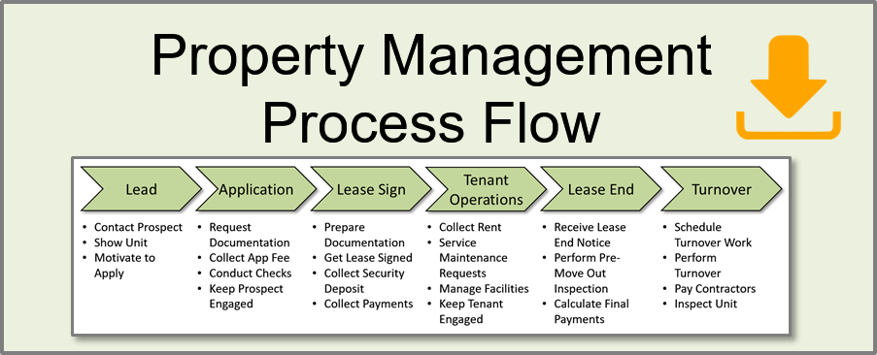

User stories:

Area | User Story
Classification | As a Finance Accountant, I want the system to automatically classify a lease as Finance/Sales-Type or Operating/Operating Lease based on the ASC 842 criteria so that I can ensure compliance with US GAAP.
Calculation | As a Finance Accountant, I want the system to calculate the initial Right-of-Use (ROU) Asset and Lease Liability based on the Incremental Borrowing Rate (IBR) so that my balance sheet is accurate on Day 1.
Journal Entries | As a Finance Accountant, I want to generate monthly journal entries (JEs) for lease liability amortization, ROU asset depreciation, and interest expense so that I can post to the General Ledger (GL) automatically.
Remeasurement | As a Finance Accountant, I want to re-measure the lease liability when a change occurs in an index-based payment so that the financial disclosure remains compliant with IFRS 16.
Reporting | As a Finance Accountant, I want to export detailed IFRS 16/ASC 842 disclosure reports (e.g., future lease payments, weighted average discount rate) so that I can fulfill statutory reporting requirements.

